**Number Concepts in High School Algebra**

**MATH5064**

**Bemidji State University**

**Meghan Brautigam**

**Edina High School**

**Meghan.brautigam@edinaschools.org**

**Executive Summary:**

This unit focuses on operations with integers. The unit starts with students learning the various divisibility rules for 2 – 10. Then the unit moves into finding the prime factorization of numbers. They will use prime factorizations to help find the greatest common factor and least common multiple of two numbers. The last part of the unit will focus on completing operations by hand. Students will review the order of operations and complete activities to practice. Then students will learn visual methods of adding, subtracting, multiplying, and dividing integers.

Throughout this unit, it is assumed that students have some prior knowledge on this material. The goal is to take what they already know and create visuals and more concrete ways to think about the problems. This unit does not deal with negative integers, so this would be a focus once students are comfortable using the methods learned in this unit on positive integers. After this unit, students would be learning about rational and irrational numbers. They would use what they learned about division and prime factorization to work with these rational and irrational numbers.

My students in Edina are seated in groups of 4 or 5 students every day. They have access to write on their desks with white board markers. I will be using this unit for my College Algebra Prep class. Even though these lessons are marked by “Days”, there is a possibility that some of these lessons may take multiple days, especially if extra practice is needed.

**MN State Standards:**

* 5.1.1.1 Divide multi-digit numbers, using efficient and generalizable procedures, based on knowledge of place value, including standard algorithms
* 6.1.1.5 Factor whole numbers; express a whole number as a product of prime factors with exponents
* 6.1.1.6 Determine greatest common factors and least common multiples.
* 7.1.2.1 Add, subtract, multiply and divide positive and negative rational numbers that are integers, fractions and terminating decimals; use efficient and generalizable algorithms
* 8.1.1.3 Determine rational approximations for solutions to problems involving real numbers
* 8.2.3.2 Justify steps in generating equivalent expressions by identifying the properties used, including the properties of algebra.

**Sample MCA Questions:**

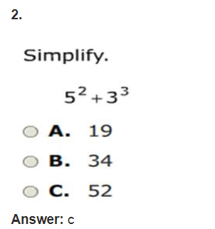

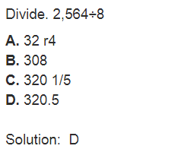

**Table of Contents**

Divisibility Rules 4–20

Prime Factorization 21–23

Greatest Common Factor 24–26

Least Common Multiple 27–29

GCF and LCM Practice 30–32

GCF and LCM Word Problems 33–34

Order of Operations 35–40

Math Magic 41–43

Addition by Hand 44–47

Greedy and Nearest Neighbor 48–49

Subtraction by Hand 50–53

Visual Multiplication 54–56

Division by Hand 57–60

How Grand is Your Total? 61–62

Pre/Post Test 63–64

**Day 1 and 2: Divisibility Rules**

**Objective:** The students will come up with the divisibility rules for 2, 3, 4, 5, 6, 7, 8, 9 and 10

**MN State Standards:**

* 5.1.1.1 Divide multi-digit numbers, using efficient and generalizable procedures, based on knowledge of place value, including standard algorithms

**Materials:**

* *Divisibility Rules* Packet

**Launch:**

1. Ask students in general if they now how a number is divisible by 2, 3, 4, etc. If any students think they have an answer, ask them to prove it.
2. Most likely students will be able to list a few, like 2, 5, and 10, but they may not be able to explain why. This lesson will help them learn the divisibility rules (and why they are true) for the numbers 2 – 10.
3. Explain base ten blocks (flats, longs, units) in case students have not worked with them before.

**Explore:**

1. Hand out the *Divisibility* Rules packet. This activity may seem like a lot, so it is important for there to be regular check-ins. This activity (throughout the two days) will be broken into five sections.
2. Section 1: Divisibility by 2, 5, and 10
   1. Students will work through the first three divisibility rules in the packet.
   2. The big ideas for these three numbers is that 2, 5, and 10 evenly divide 100 and 10 so it does not matter what numbers I have in the 100’s and 10’s place, I am only concerned if the last digit is divisible by 2, 5, and 10.

**Share:**

1. Once students have had time to work out these rules, we will briefly share them with the class. Before moving on to the next section, it is important to make sure that every group has the correct rule written down for the divisibility of 2, 5, and 10.

**Explore:**

1. Section 2: Divisibility by 4
   1. In this case, 100 evenly divides by 4, so it does not matter what digit we have in the 100’s place.
   2. The 10’s place however, does not divide by 4. In order for a number to be divisible by 4, the 10’s digit and the 1’s digits combined have to be divisible by 4. Therefore, we just need to make sure the last two digits of our number creates a number that is divisible by 4.

**Share:**

1. Once again, we will talk briefly as a class to make sure everyone came up with the same rule before moving on to the next section.

**Explore:**

1. Section 3: Divisibility by 3 and 9
   1. These two cases are slightly different from the earlier cases. Rather than looking at the last digit, students need to take into account all of the digits.
   2. As they fill out their packets, they should realize that a number is divisible by 9 if the digits (found by looking at what’s left unshaded) add up to be a number divisible by 9.
   3. The same works for 3, the digits must add up to a number divisible by 3.

**Share:**

1. The students will share and double check what they got for their divisibility rules for these two numbers. Students should make sure they have these written down correctly before moving on.

**Explore:**

1. Section 4: Divisibility by 6
   1. Students should make the connection that 6 = 2 x 3. This part of the exploration should not take that long because they are just filling out a chart.
   2. They should see that any number that is divisible by both 2 and 3 will also be divisible by 6.

**Share:**

1. Just like the rest of the rules, students should check that they got the right rule before moving on to the next section.

**Explore:**

1. Section 5: Divisibility by 7 and 8
   1. These two are not as easy as the others. These should be worked on as a class. The same process can be used for both 7 and 8.
   2. Students will answer the first part of the worksheet to see if they can see the relationship between what’s left unshaded and how it relates to the digits.
   3. As a class, show a formal proof on why the divisibility rule works.
      1. For a number to be divisible by 7,

Let ABC be a 3-digit number, then

100A + 10B + C

= (98 + 2)A + (7 + 3)B + C

=98A + 2A + 7B + 3B + C

=98A + 7B + 2A + 3B + C

=7(14A + B) + 2A + 3B + C

We know the first part is divisible by 7, so in order for the whole number to be divisible by 7, 2 times the 100’s digit + 3 times the 10’s digit plus 1’s digit must be divisible by 7.

Students would have seen that 2 units were left unshaded in the 100’s block and 3 units were left unshaded in the 10’s block.

* 1. 8 is similar but you get 4A + 2B + C. Some people also like to use the rule that the last three digits must be divisible by 8, but this shows us why.
  2. Some students may not follow the proof, but some students will and it provides justification for why these rules work.

**Summary:**

1. Students should know the following divisibility rules:
   1. 2: the last digit is divisible by 2, or even
   2. 3: the sum of the digits is divisible by 3
   3. 4: the last two digits form a number divisible by 4
   4. 5: the last digit is 0 or 5
   5. 6: the number is both divisible by 2 and 3
   6. 7: 2A + 3B + C is divisible by 7, where ABC represent the digits
   7. 8: 4A + 2B + C is divisible by 8, where ABC represents the digits
   8. 9: the sum of the digits is divisible by 9
   9. 10: the last digit is 0

***Adapted from: NCTM Investigations using Base Ten Blocks – Divisibility Tests***

**Divisibility by 2**

**1. Is 124 divisible by 2?** Group the flat, long, and units by 2 to show whether or not 124 is divisible by 2.

1. How many units were remaining when you grouped the flat by 2?_______

2. How many units were remaining when you grouped the longs by 2? _______

3. How many units do you have? _______

4. Can you find any more groups of 2 with what’s remaining? If so, mark them.

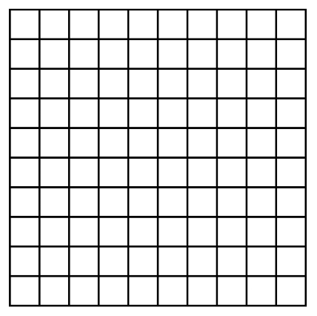







Is 124 divisible by 2? ____________

**What observations can you make so far?**

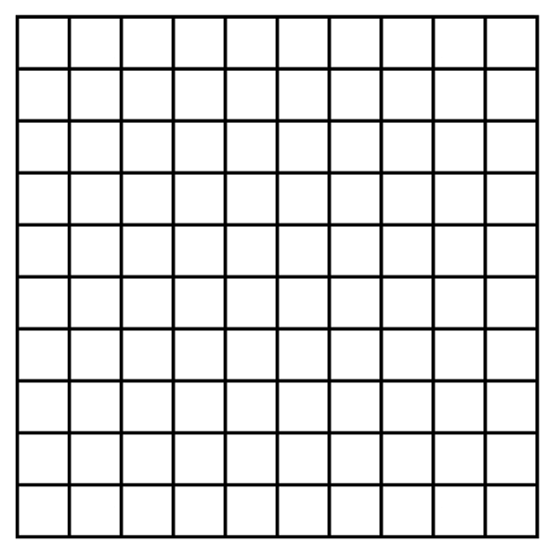**2. Is 137 divisible by 2?** Group the flat, long, and units by 2 to show whether or not 137 is divisible by 2.

1. How many units were remaining when you grouped the flat by 2?_______

2. How many units were remaining when you grouped the longs by 2? _______

3. How many units do you have? _______

4. Can you find any more groups of 2 with what’s remaining? If so, mark them.

Is 137 divisible by 2? ____________

**What observations can you make so far?**

**3. Is 120 divisible by 2?** Group the flat, long, and units by 2 to show whether or not 120 is divisible by 2.

1. How many units were remaining when you grouped the flat by 2?_______

2. How many units were remaining when you grouped the long by 2? _______

3. How many units do you have? _______

4. Can you find any more groups of 2 with what’s remaining? If so, mark them.

Is 120 divisible by 2? ____________

**4.** What similarities can you find between the three examples? What will always be true?

**5.** What differences can you find between the three examples? What caused some numbers to be divisible by 2 and the others to not be divisible by 2?

**A number is divisible by 2 if: _____________________________________________________________**

**How do you know?**

**Divisibility by 5**

**1. Is 146 divisible by 5?** Group the flat, long, and units by 5 to show whether or not 146 is divisible by 5.

1. How many units were remaining when you grouped the flat by 5?_______

2. How many units were remaining when you grouped the longs by 5? _______

3. How many units do you have? _______

4. Can you find any more groups of 5 with what’s remaining? If so, mark them.





Is 146 divisible by 5? ____________

**What observations can you make so far?**

**2. Is 115 divisible by 5?** Group the flat, long, and units by 5 to show whether or not 115 is divisible by 5.

1. How many units were remaining when you grouped the flat by 5?_______

2. How many units were remaining when you grouped the long by 5? _______

3. How many units do you have? _______

4. Can you find any more groups of 5 with what’s remaining? If so, mark them.

Is 115 divisible by 5? ____________

**What observations can you make so far?**

**3. Is 110 divisible by 5?** Group the flat, long, and units by 5 to show whether or not 110 is divisible by 5.

1. How many units were remaining when you grouped the flat by 5?_______

2. How many units were remaining when you grouped the long by 5? _______

3. How many units do you have? _______

4. Can you find any more groups of 5 with what’s remaining? If so, mark them.

Is 110 divisible by 5? ____________

**4.** What similarities can you find between the three examples? What will always be true?

**5.** What differences can you find between the three examples? What caused some numbers to be divisible by 5 and the others to not be divisible by 5?

**A number is divisible by 5 if: _____________________________________________________________**

**How do you know?**

**Divisibility by 10**

**1. Is 130 divisible by 10?** Group the flat, long, and units by 10 to show whether or not 130 is divisible by 10.

1. How many units were remaining when you grouped the flat by 10?_______

2. How many units were remaining when you grouped the longs by 10? _______

3. How many units do you have? _______

4. Can you find any more groups of 10 with what’s remaining? If so, mark them.



Is 130 divisible by 10? ____________

**What observations can you make so far?**

**2. Is 122 divisible by 10?** Group the flat, long, and units by 10 to show whether or not 122 is divisible by 10.

1. How many units were remaining when you grouped the flat by 10?_______

2. How many units were remaining when you grouped the longs by 10? _______

3. How many units do you have? _______

4. Can you find any more groups of 10 with what’s remaining? If so, mark them.







Is 122 divisible by 10? ____________

**What observations can you make so far?**

**3. Is 145 divisible by 10?** Group the flat, long, and units by 10 to show whether or not 145 is divisible by 10.

1. How many units were remaining when you grouped the flat by 10?_______

2. How many units were remaining when you grouped the longs by 10? _______

3. How many units do you have? _______

4. Can you find any more groups of 10 with what’s remaining? If so, mark them.





Is 145 divisible by 10? ____________

**3.** What similarities can you find between the three examples? What will always be true?

**4.** What differences can you find between the three examples? What caused some numbers to be divisible by 10 and the others to not be divisible by 10?

**A number is divisible by 10 if: ____________________________________________________________**

**How do you know?**

**Divisibility by 4**

**1. Is 112 divisible by 4?** Group the flat, long, and units by 4 to show whether or not 112 is divisible by 4.

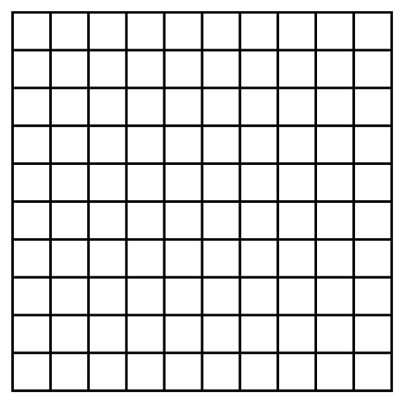

1. How many units were remaining when you grouped the flat by 4?_______

2. How many units were remaining when you grouped the long by 4? _______

3. How many units do you have? _______

4. Can you find any more groups of 4 with what’s remaining? If so, mark them.





Is 112 divisible by 4? ____________

**What observations can you make so far?**

**2. Is 132 divisible by 4?** Group the flat, long, and units by 4 to show whether or not 132 is divisible by 4.



1. How many units were remaining when you grouped the flat by 4?_______

2. How many units were remaining when you grouped the longs by 4? _______

3. How many units do you have? _______

4. Can you find any more groups of 4 with what’s remaining? If so, mark them.





Is 132 divisible by 4? ____________

**What observations can you make so far?**

**3. Is 148 divisible by 4?** Group the flat, long, and units by 4 to show whether or not 148 is divisible by 4.



1. How many units were remaining when you grouped the flat by 4?_______

2. How many units were remaining when you grouped the longs by 4? _______

3. How many units do you have? _______

4. Can you find any more groups of 4 with what’s remaining? If so, mark them.



Is 148 divisible by 4?__________

**4.** What similarities can you find between the three examples? What will always be true?

**5.** What differences can you find between the three examples? What caused some numbers to be divisible by 4 and the others to not be divisible by 4?

**A number is divisible by 4 if: ____________________________________________________________**

**How do you know?**

**Divisibility by 9**

**1. Is 135 divisible by 9?** Group the flat, long, and units by 9 to show whether or not 135 is divisible by 9.



1. How many units were remaining when you grouped the flats by 9?_______

2. How many units were remaining when you grouped the long by 9? _______

3. How many units do you have? _______

4. Can you find any more groups of 9 with what’s remaining? If so, mark them.





Is 135 divisible by 9? ____________

**What observations can you make so far?**

**2. Is 234 divisible by 9?** Group the flat, long, and units by 9 to show whether or not 234 is divisible by 9.



1. How many units were remaining when you grouped the flat by 9?_______

2. How many units were remaining when you grouped the long by 9? _______

3. How many units do you have? _______

4. Can you find any more groups of 9 with what’s remaining? If so, mark them.







Is 234 divisible by 9? ____________

**What observations can you make so far?**

**3. Is 117 divisible by 9?** Group the flat, long, and units by 9 to show whether or not 117 is divisible by 9.



1. How many units were remaining when you grouped the flat by 9?_______

2. How many units were remaining when you grouped the long by 9? _______

3. How many units do you have? _______

4. Can you find any more groups of 9 with what’s remaining? If so, mark them.









Is 117 divisible by 9?__________

**What observations can you make so far?**

**4. Is 235 divisible by 9?** Group the flat, long, and units by 9 to show whether or not 235 is divisible by 9.

1. How many units were remaining when you grouped the flat by 9?_______

2. How many units were remaining when you grouped the long by 9? _______

3. How many units do you have? _______

4. Can you find any more groups of 9 with what’s remaining? If so, mark them.







Is 235 divisible by 9?__________

**5.** What similarities can you find between the four examples? What will always be true?

**6.** What differences can you find between the four examples? What caused some numbers to be divisible by 9 and the others to not be divisible by 9?

**A number is divisible by 9 if: ____________________________________________________________**

**How do you know?**

**Divisibility by 3**

**1. Is 138 divisible by 3?** Group the flat, long, and units by 3 to show whether or not 138 is divisible by 3.



1. How many units were remaining when you grouped the flats by 3?_______

2. How many units were remaining when you grouped the long by 3? _______

3. How many units do you have? _______

4. Can you find any more groups of 3 with what’s remaining? If so, mark them.





Is 138 divisible by 3? ____________

**What observations can you make so far?**

**2. Is 243 divisible by 3?** Group the flat, long, and units by 3 to show whether or not 243 is divisible by 3.



1. How many units were remaining when you grouped the flat by 3?_______

2. How many units were remaining when you grouped the long by 3? _______

3. How many units do you have? _______

4. Can you find any more groups of 3 with what’s remaining? If so, mark them.







Is 243 divisible by 3? ____________

**What observations can you make so far?**

**3. Is 125 divisible by 3?** Group the flat, long, and units by 3 to show whether or not 125 is divisible by 3.



1. How many units were remaining when you grouped the flat by 3?_______

2. How many units were remaining when you grouped the long by 3? _______

3. How many units do you have? _______

4. Can you find any more groups of 3 with what’s remaining? If so, mark them.



Is 125 divisible by 3?__________

**What observations can you make so far?**

**4. Is 312 divisible by 3?** Group the flat, long, and units by 3 to show whether or not 312 is divisible by 3.

1. How many units were remaining when you grouped the flat by 3?_______

2. How many units were remaining when you grouped the long by 3? _______

3. How many units do you have? _______

4. Can you find any more groups of 3 with what’s remaining? If so, mark them.







Is 312 divisible by 3?__________

**5.** What similarities can you find between the four examples? What will always be true?

**6.** What differences can you find between the four examples? What caused some numbers to be divisible by 3 and the others to not be divisible by 3?

**A number is divisible by 3 if: ____________________________________________________________**

**How do you know?**

**Divisibility by 6**

**1**. We have created a divisibility rule for 2 and 3. What are they?

A number is divisible by 2 if ________________________________________________________

A number is divisible by 3 if ________________________________________________________

**2.** Fill out the following table. We know that 2 x 3 = 6, so can we use these numbers to help us figure out a divisibility rule for 6?

|  |  |  |  |
| --- | --- | --- | --- |
| **Number** | **Divisible by 2?** | **Divisible by 3?** | **Divisible by 6?** |
| 18 |  |  |  |
| 46 |  |  |  |
| 72 |  |  |  |
| 15 |  |  |  |
| 42 |  |  |  |
| 51 |  |  |  |
| 64 |  |  |  |
| 24 |  |  |  |

**3**. What do you notice from you table?

**A number is divisible by 6 if: ____________________________________________________________**

**How do you know?**

**Divisibility by 8**

1. Group the following into groups of 8.

1. How many units were remaining when you grouped the flat by 8?_______

2. How many units were remaining when you grouped the long by 8? _______

3. How many units do you have? _______



2. We know everything that is shaded is divisible by 8. We also know for every 100, there are 4 unshaded units, for every 10 there are 2 unshaded units, and then we have our regular units left that should be kept unshaded.

a. If our number is 368, how many total units are unshaded in the 100’s?

b. How many total units are unshaded in the 10’s?

c. How many regular units do we have unshaded?

d. Do you think 368 is divisible by 8? In other words, can you group what’s remaining (unshaded) into groups of 8 with none left unshaded?

e. If we let ABC represent our 3-digit number, can you think of an algebraic expression we could use to represent what you did in steps a – c?

**A number is divisible by 8 if: ___________________________________________________________**

**Proof:**

**Divisibility by 7**

1. Group the following into groups of 7.

1. How many units were remaining when you grouped the flat by 7?_______

2. How many units were remaining when you grouped the long by 7? _______

3. How many units do you have? _______



2. We know everything that is shaded is divisible by 7. We also know for every 100, there are 2 unshaded units, for every 10 there are 3 unshaded units, and then we have our regular units left that should be kept unshaded.

a. If our number is 259, how many total units are unshaded in the 100’s?

b. How many total units are unshaded in the 10’s?

c. How many regular units do we have unshaded?

d. Do you think 259 is divisible by 7? In other words, can you group what’s remaining (unshaded) into groups of 7 with none left unshaded?

e. If we let ABC represent our 3-digit number, can you think of an algebraic expression we could use to represent what you did in steps a – c?

**A number is divisible by 7 if: ___________________________________________________________**

**Proof:**

**Day 3: Prime Factorization**

**Objective:** Students will learn how to deconstruct a number into its prime factorization

**MN State Standards:**

* 6.1.1.5 Factor whole numbers; express a whole number as a product of prime factors with exponents

**Materials:**

* Colored Pencils
* *Prime Numbers Under 100* chart
* *Prime Factors* worksheet

**Launch:**

1. Define what a prime number is. For our purposes, we will look at numbers greater than 1.
2. Hand out the *Prime Numbers Under 100* chart and colored pencils*.*
3. With their group, students will start at 2 and find all of the prime numbers under 100. They can use a calculator if they need it. All prime numbers should be shaded in with a colored pencil.

**Share:**

1. Have one group share which numbers they found were prime along with the method they used to decide which numbers were prime.
2. If any groups used a different method or disagreed on any numbers, have them share as well.
3. Before moving on, make sure all students agree on which numbers are prime and make sure they aren’t missing any: 2,3,5,7,11,13,17,19,23,29,31,37,41,43,47,53,59,61,67,71,73,79,83,89,97

**Explore:**

1. Without telling students how to find the prime factorization of a number, hand out the *Prime Factors* worksheet.
2. With their groups, have the students find the prime factorization of the numbers. They can use whatever method they want and they can write their final answer however they like.
3. Make sure to walk around to make sure students are breaking the numbers down as far as possible and referring to their *Prime Numbers Under 100* chart if they are unsure.
4. Students can use the worksheet to keep track of the different methods they used.
5. Encourage them to use their divisibility rules to determine which numbers will divide into what they are trying to break down.

**Share:**

1. Have groups share the method they used to find the prime factorization.
2. Every group should share their process, even if it has already been used. Even if they all used the tree, they probably broke the numbers down in a different way.
3. On the back/blank side of the worksheet, students can keep track of methods that other students in the class used.

**Summary:**

1. By the end of the lesson, the students should understand that the prime factorization of a number is written as the prime factors of the numbers multiplied together.
2. Students must understand that every number written in the prime factorization must be prime.
3. Students can write their answers with every factor to the first power, or they can combine the same factors.
   1. For example, 20 can be written as 2x2x5 or 22x5.
4. Let them know it is standard practice to write the factors from smallest to largest.

***This lesson was adapted from the Math = Love Blog at*** [***http://mathequalslove.blogspot.com/2017/02/reviewing-prime-factorization-at-high.html***](http://mathequalslove.blogspot.com/2017/02/reviewing-prime-factorization-at-high.html)

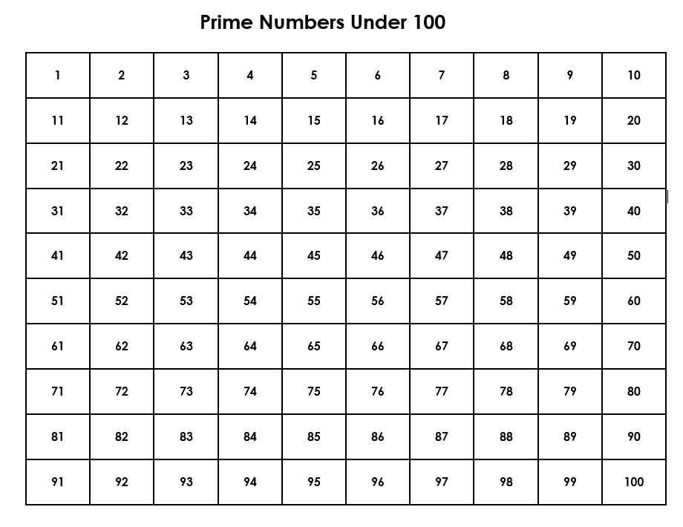

**Prime Factors**

Find the prime factorization of the following numbers. Be sure to use the space provided to show how you solved each problem. Try to solve the problems in different ways if you can.

|  |  |
| --- | --- |
| **1.** 360  Prime Factorization: _______________ | **2.** 408  Prime Factorization: _______________ |
| **3.** 2622  Prime Factorization: _______________ | **4.** 4320  Prime Factorization: _______________ |
| **5.** 5400  Prime Factorization: _______________ | **6.** 32340  Prime Factorization: _______________ |

**Day 4: Greatest Common Factor**

**Objective:** Students will be able to find the greatest common factor between two numbers

**MN State Standards:**

* 6.1.1.6 Determine greatest common factors and least common multiples.

**Materials:**

* *Greatest Common Factor* worksheet

**Launch:**

1. Review what factors are by having them list the factors of 20: 1, 2, 4, 5, 10, 20
2. Next, have students review finding the prime factorization of a number.
   1. Example: 27720 = 2x2x2x3x3x5x7x11
3. Finally, to review Venn Diagrams, have students create a Venn diagram comparing fish and cats. They will need to understand how Venn Diagrams work, so have them work with their group to review using this example before moving on.

**Explore:**

1. Hand out *Greatest Common Factor* worksheet. Students should work with their groups to complete both sides of the worksheet.
2. By the end of the worksheet, they should have a theory on how they can use Venn diagrams to find the greatest common factor between two numbers.
3. Have students demonstrate their theory by coming up with an example to show the class.

**Share:**

1. Once all students finish their worksheets, they should share their theory with the class by writing it on the board along with their example.
2. Students should compare their theory with other groups. If there are any differing theories, then they should be discussed as a class to see if they are correct.
   1. This could involve double checking that students found the correct greatest common factor, that their prime factorization was correct, and that their Venn diagram was correct for each problem.

**Summary:**

1. By the end of the lesson, students should know that to find the greatest common factor:
   1. First find the prime factorization of each number.
   2. Next, put the prime numbers in a Venn diagram.
   3. Finally, multiply the intersection (what they share) to find the gcf.
   4. Example) the greatest common factor of 24 and 108 is 12 because…

24 = 2x2x2x3

108 = 2x2x3x3x3

**108**

**24**

**2**

**2**

**3**

**3**

**3**

**2**

**GCF(24,108) = 2x2x3 = 12**

***This lesson was adapted from NCTM***

***Illuminations – The Venn Factor***

**Greatest Common Factor**

1. In your own words, what do you think is the definition of a greatest common factor (gcf) between two numbers?

2. Find **all** the factors of 8: __________________ Find **all** the factors of 12:___________________

3. What do you think the greatest common factor of 8 and 12 is?__________

Why?

Get your answer checked by the teacher before moving on.

4. Find the prime factorization of 8: Find the prime factorization of 12:

_____________________________ _____________________________

5. Create a Venn Diagram between 8 and 12 using their prime factors.

**12**

**8**

6. Using your answer from question 3, is there a way you could get this number (the greatest common factor) from the Venn Diagram?

**Test your theory from question 6 with a couple more examples.**

7. Find **all** the factors of 42: __________________ Find **all** the factors of 70:___________________

8. What do you think the greatest common factor of 42 and 72 is?__________

9. Find the prime factorization of 42: Find the prime factorization of 70:

_____________________________ _____________________________

10. Create a Venn Diagram between 42 and 70 using their prime factors.

**70**

**42**

11. Does your theory from question 6 work in this example? If not, come up with another theory on how to use Venn Diagrams to find the greatest common factor.

**18**

**6**

12. Repeat this process for 6 and 18.

a. Factors of 6: __________________

b. Factors of 18: _________________

c. GCF(6,18) = __________

d. Prime Factorization of 6: _______________

e. Prime Factorization of 18: ______________

**Conclusion: How do you find the greatest common factor of two numbers using Venn Diagrams?**

**Day 5: Least Common Multiple**

**Objective:** Students will be able to find the least common multiple between two numbers

**MN State Standards:**

* 6.1.1.6 Determine greatest common factors and least common multiples.

**Materials:**

* *Least Common Multiple* worksheet

**Launch:**

1. Show students the following clip: <https://www.youtube.com/watch?v=j0A-DeOYOJ0>
2. Essentially, the customer is upset because he can buy a hot dog package with 8 hot dogs, but he can only buy a package of 12 buns, not 8.
3. Ask: How many hot dog packages and hot dog bun packages should he purchase so that there are no leftover hot dogs or buns?
4. Students should work with their groups to come up with an answer. At this point, they may or may not know that they are finding the least common multiple.

**Share:**

1. Students will write their answer on the board in their groups with the work to show their processes.
2. Have groups who solved the problem differently explain how they got their answer.
3. Before moving on, let the students know that they found the least common multiple.

**Explore:**

1. Pass out the *Least Common Multiple* worksheet. Have students work through it in their groups to come up with a theory on how to find the least common multiple of two numbers using Venn diagrams.
2. Review what a multiple is in case students do not know.

**Share:**

1. Similar to the previous day, students should share the theory they came up with and check with other groups.
2. Any differing theories should be discussed to determine if they are correct.

**Summary:**

1. By the end of the lesson, students should know how to find the least common multiple:
   1. Find the prime factorization of each number.
   2. Put the prime numbers into a Venn diagram.
   3. Multiply every number inside the circles to find the lcm.
   4. Example) the least common multiple of 24 and 108 is 216 because….

24 = 2x2x2x3

108 = 2x2x3x3x3

**108**

**24**

**2**

**2**

**3**

**3**

**3**

**2**

**LCM(24,108) = 2x2x2x3x3x3 = 216**

***This lesson was adapted from NCTM***

***Illuminations – The Venn Factor***

**Least Common Multiple**

1. In your own words, what do you think is the definition of a least common multiple (lcm) between two numbers?

2. Find the first six multiples of 4: __________________

Find the first six multiples of 10:___________________

3. What do you think the least common multiple of 4 and 10 is?__________

Why?

Get your answer checked by the teacher before moving on.

4. Find the prime factorization of 4: Find the prime factorization of 10:

_____________________________ _____________________________

5. Create a Venn Diagram between 4 and 10 using their prime factors.

**10**

**4**

6. Using your answer from question 3, is there a way you could get this number (the least common multiple) from the Venn Diagram?

**Test your theory from question 6 with a couple more examples.**

7. Find the first six multiples of 18: __________________

Find the first six multiples of 24:___________________

8. What do you think the least common multiple of 18 and 24 is?__________

9. Find the prime factorization of 18: Find the prime factorization of 24:

_____________________________ _____________________________

10. Create a Venn Diagram between 18 and 24 using their prime factors.

**24**

**18**

11. Does your theory from question 6 work in this example? If not, come up with another theory on how to use Venn Diagrams to find the least common multiple.

**42**

**14**

12. Repeat this process for 14 and 42.

a. Multiples of 14: __________________

b. Multiples of 42: _________________

c. LCM(14,42) = __________

d. Prime Factorization of 14: _______________

e. Prime Factorization of 42: ______________

**Conclusion: How do you find the least common multiple of two numbers using Venn Diagrams?**

**Day 6: GCF and LCM Practice**

**Objective:** Students will practice finding the GCF and LCM between two numbers

**MN State Standards:**

* 6.1.1.6 Determine greatest common factors and least common multiples.

**Materials:**

* *Zombie Attack Game*
* Dice

**Launch:**

1. The activities from the previous two days may take longer than a single class period. Students should finish these activities first.
2. Before moving on, all students in the class need to know how to find the GCF and LCM of two numbers using Venn diagrams.

**Explore:**

1. Once the class is ready to practice finding the GCF and LCM, hand out the *Zombie Attack Game.*
2. Students will play this game for the remainder of class to practice finding the GCF and LCM.

**Share:**

1. As students play, their partner should be checking their work to make sure they solved each problem correctly.
2. Even if a problem has been done already, students should resolve it as if they haven’t done it yet.

**Summary:**

1. This game is meant for students to review what they have learned.
2. By the end of the day, students should feel comfortable with finding the prime factorization of any number, creating a Venn diagram between two numbers, and then figuring out the greatest common factor and least common multiple using this Venn diagram.

***Adapted from Math Games 4 Children – Author: Mphoweh Jude***

[***http://mathgames4children.com/Printables/Board%20Games/Zombie%20board%20games/HCF.pdf***](http://mathgames4children.com/Printables/Board%20Games/Zombie%20board%20games/HCF.pdf)

**Greatest Common Factor and Least Common Multiple Zombie Board Game**

**Rules of the Game**

1. Roll the dice and count ahead according to the number that shows up.

2. When a player lands on a space, he/she find the greatest common factor and least common multiple of the numbers on the space within the determined time.

a. If they do this incorrectly (because their partner will be checking their answer), then they go back to where they were before that turn.

3. The instructions for the other spaces are as follows:

a. **Lose a turn:** the player loses a turn to play



b. **Go forward:**



c. **Go backward:**



d. **Zombie:** landing on the zombie sends the player back to start.

Restarting is no fun when your opponent is advancing.

e. **Trade Places:** This can be good or bad. The player who lands on this space swaps with the opponent. Trading places with an opponent who is ahead in the game is good. Trading places with an opponent who is behind is no fun.

4. To finish the game, the player must get the exact number on the dice to END. If the player has more, the player has to count forward and backwards.

a. For example, if a player is at space 31, the player needs to roll and get 4 to finish. If the player has 6 for example, the player counts forward 4 and 2 backwards to space 33.

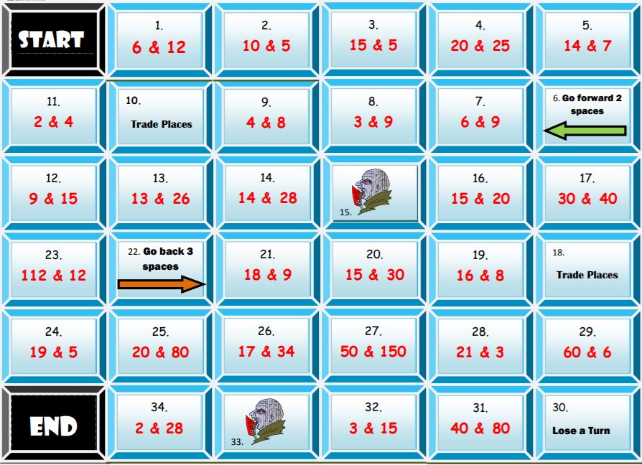

**Day 7: GCF and LCD Word Problems**

**Objective:** Students will be able to determine if a word problem requires the greatest common factor or the least common multiple to answer the question.

**MN State Standards:**

* 6.1.1.6 Determine greatest common factors and least common multiples.

**Materials:**

* *GCF and LCM Word Problems* worksheet

**Launch:**

1. Have students review calculating the GCF and LCD of 18 and 30.

**Explore:**

1. Students will work in their groups to come up with two word problems.
2. The first word problem should require the need for the greatest common factor. The second should require the need for the least common multiple.
3. In the front of the room, the white board should be divided in two. One side will be where students write their GCF problem, the other side will be where they write their LCM problem.

**Share:**

1. Once all students have their problems on the board, students will work in their groups to see if they think every problem is listed under the correct title (GCF or LCM). If a group thinks a problem has been misplaced, then the class should discuss and decide where it should go.
2. Once students are okay with where all the problems are placed, students should discuss in their groups any similarities they see in the problems on each side.
   1. Is there a way to know a problem is asking for the GCF?
   2. Is there a way to know a problem is asking for the LCM?
   3. Are there key words, phrases, characteristics of a problem to help us determine whether or not to use GCF or LCD?
3. Groups should take turns sharing what similarities or “rules” they found to help solve a GCF or LCM word problem.

**Summary:**

1. By the end of the lesson, students should notice the following patterns:
   1. GCF: trying to find the greatest number of ways to group items or sort them
   2. LCM: often relates to time, looking at when two things will overlap in the future
2. Students will finish by completing the *GCF and LCM Word Problems* worksheet.

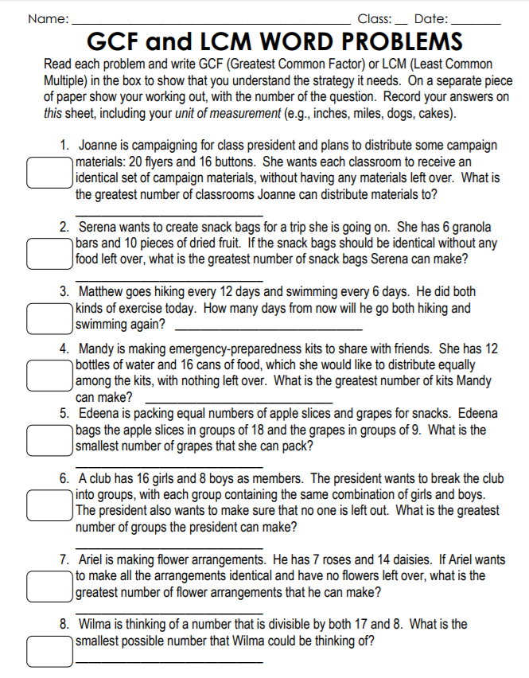

**Day 8: Order of Operations**

**Objective:** Students will be able to use the order of operations to simplify algebraic expressions

**MN State Standards:**

* 8.2.3.2 Justify steps in generating equivalent expressions by identifying the properties used, including the properties of algebra.

**Materials:**

* *Order of Operations Dice Game* game boards
* Dice

**Launch:**

1. Students at this level should be familiar with the operations of integers (addition, subtraction, multiplication, and division).
2. They have most likely seen order of operations before, but if not review PEMDAS.
   1. Parenthesis, exponents, multiplication and division (left to right), and addition and subtraction (left to right).
   2. Practice with the following examples:

$14+18÷2×18-7=169$

$\left(9+33-6\right)÷6-3^{2}=-3$

**Explore:**

1. Break students up into pairs. Give every pair of students three dice, and give each student an *Order of Operations Game* sheet. There are five different game boards.
2. Directions for how this game works are on the bottom of the page.
3. Students should play with their partner a couple times, using a different game board each time, and they should keep note of any strategy they are using when placing their numbers.

**Share:**

1. After students have played for a couple rounds, have them discuss their strategies with their partner.
2. Have the different pairs share their strategies with the class. How did they pick which line to use first? How did they decide where to place the numbers?
3. After the class has shared their strategies, let the students play again to try out any new strategies they learned.

**Summary:**

1. By the end of the day, students should feel comfortable using the order of operations.

***Rules of the Order of Operations Game:***

1. Each player starts with the same game board.
2. Player 1 rolls the dice three, four, or five times, depending on how many blanks there are on each line of that particular game board. Keep track of the numbers rolled.
3. Both players fill in those three, four, or five numbers on their game board.
   1. Students can choose where they put the numbers, but they all have to go on the same line. Essentially, numbers from the same roll go in the same horizontal.
   2. Once both players are satisfied with their placement, that round is done and those numbers may not be moved.
4. Next, Player 2 will roll the dice the designated number of times and each player will place the numbers where they choose on one of the lines.
5. This process will continue until all lines are filled. Each player should have rolled the dice for three rounds.
6. The player with the largest sum from their six lines wins the game.

***Adapted from TeachersPayTeachers***

***Author: Creative Inclusion – Order of Operations Game***

|  |
| --- |
| **Order of Operations Dice Game Board 1** |
| **Order of Operations Dice Game Board 1** |
| **Order of Operations Dice Game Board 2** |
| **Order of Operations Dice Game Board 2** |
| **Order of Operations Dice Game Board 3** |
| **Order of Operations Dice Game Board 3** |
| **Order of Operations Dice Game Board 4** |
| **Order of Operations Dice Game Board 4** |
| **Order of Operations Dice Game Board 5** |
| **Order of Operations Dice Game Board 5** |

**Day 9: Math Magic**

**Objective:** Students will be able to use order of operations to create algebraic expressions

**MN State Standards:**

* 8.2.3.2 Justify steps in generating equivalent expressions by identifying the properties used, including the properties of algebra.

**Materials:**

* *Math Magic* worksheet

**Launch:**

1. Have students take out a piece of paper and read the steps aloud as they follow along:
   1. Make sure they show their work at each step so that they can refer back to it.
   2. Pick any number.
   3. Double it.
   4. Add 10.
   5. Divide that by 2.
   6. Take away your original number.
   7. They should be left with 5.
2. Ask the students why this happened. Have them work with their groups to come up with an algebraic expression, not simplified, to represent this process.

**Share:**

1. Have students write their expression on the board.
2. Most students should come up with something along the lines of: . Then, work through the order of operations to show how the final answer will be 5 every time.
3. Make sure every group understands how this algebraic expression represents the problem and how it simplifies to equal 5 before moving on.

**Explore:**

1. Hand out the *Math Magic* worksheet.
2. Students will work in their groups to complete their worksheet.
3. For each problem, they should complete a numerical example first. Then they should show the original algebraic expression and how it simplifies down to what the answer should be.

**Share:**

1. Groups will trade the problem they created with another group and they will solve the other group’s problem.
2. They should include the same three pieces that they did on the worksheet.
3. Each team should double check their opponent’s answers to see if they are correct.

**Summary:**

1. By the end of the lesson, students should feel comfortable creating algebraic expressions and simplifying them. The goal is for students to know where to put the different operations to produce the desired outcome.

**Math Magic**

For each of the following: (1) complete a numerical example, (2) create an algebraic expression for any number you choose, n, that is not simplified, (3) show how this algebraic expression simplifies to the final outcome.

1. Think of a number.

2. Think of a number.

Subtract 1.

Multiply by 3.

Add 12.

Divide by 3.

Add 5.

Subtract your original number.

Your answer should be 8.

**Numeric Example:**

**Algebraic Expression:**

**Simplify the expression:**

Multiply 3.

Add 45.

Double it.

Take away your original number.

Your answer should be 15.

**Numeric Example:**

**Algebraic Expression:**

**Simplify the expression:**

3. Think of a number.

4. Think of 2 single digit numbers.

Take one number and double it.

Add 5.

Multiply by 5.

Add the second number.

Subtract 4.

Subtract 21.

Your answer should be your 2 single digit numbers

**Numeric Example:**

**Algebraic Expression:**

**Simplify the expression:**

Add the next highest number.

Add 9.

Divide by 2.

Subtract your original number.

Your answer should be 5.

**Numeric Example:**

**Algebraic Expression:**

**Simplify the expression:**

**Create your own!** Create your own math magic problem that uses different algebraic operations. Make sure you can prove why it works so you can help your classmates if they are struggling.

**Day 10: Addition by Hand**

**Objective:** Students will be able to add and subtract integers by hand without a calculator

**MN State Standards:**

* 7.1.2.1 Add, subtract, multiply and divide positive and negative rational numbers that are integers, fractions and terminating decimals; use efficient and generalizable algorithms
* 8.1.1.3 Determine rational approximations for solutions to problems involving real numbers

**Materials:**

* *Addition by Hand* worksheet
* Colored Pencils (optional)

**Launch:**

1. Students will not be able to use a calculator.
2. Ask students to add 342 + 549. Have students check their answer with their neighbor and briefly discuss their method with their partner.
3. There will be further discussion on this at the end of class.

**Explore:**

1. Hand out the *Addition by Hand* worksheet.
2. Students should work through the worksheet with their partner.
3. The first part has them use an area model to visualize what the sum of two numbers looks like. It will be helpful if they use different colors to represent the different place values.
4. The final part has them just complete the addition symbolically.

**Share:**

1. Have students add 342 + 549 again. Have them discuss with their partner to see if their answer or method changed.
2. Partners should share with the class if/how their method changed from when they added the two numbers at the beginning of class with how they added them at the end of class.

**Summary:**

1. The goal of using the area model is that students visualize how a number is broken down into 100’s, 10’s and 1’s.
2. They should be familiar with breaking down a number into simpler parts because this will help them with subtraction, visual multiplication, and division later in the unit.
3. For the rest of the unit, students will not be able to use calculators, so they need to be comfortable with this addition by hand.

**Addition by Hand**

|  |
| --- |
| Image result for ten by ten grid 42 + 36 =  Image result for ten by ten gridImage result for ten by ten grid  + =  **Estimate: Symbolic:** |
| Image result for ten by ten grid 64 + 28 =  Image result for ten by ten gridImage result for ten by ten grid  + =  **Estimate: Symbolic:** |
| Image result for ten by ten grid 22 + 49 =  Image result for ten by ten gridImage result for ten by ten grid  + =  **Estimate: Symbolic:** |
| Image result for ten by ten grid 67 + 59 =  Image result for ten by ten gridImage result for ten by ten grid  + =  **Estimate: Symbolic:** |
| Image result for ten by ten gridImage result for ten by ten grid 73 + 86 =  Image result for ten by ten gridImage result for ten by ten grid  + =  **Estimate: Symbolic:** |

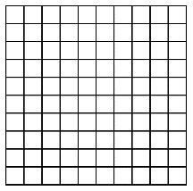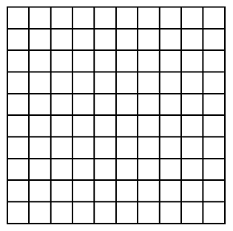 152 + 177 =

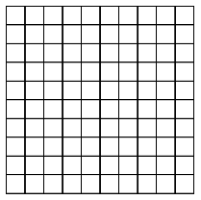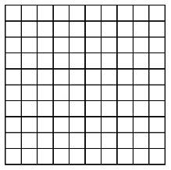

+ =

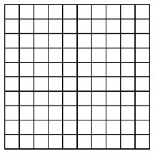

**Estimate: Symbolic:**

1. 2.

3. 4.

5. 6.

7. 8.

9. 10.

**Day 11: Greedy and Nearest Neighbor**

**Objective:** Students will be able to find the shortest distance or lowest price between a series of stops using the greedy or nearest neighbor method

**MN State Standards:**

* 7.1.2.1 Add, subtract, multiply and divide positive and negative rational numbers that are integers, fractions and terminating decimals; use efficient and generalizable algorithms
* 8.1.1.3 Determine rational approximations for solutions to problems involving real numbers

**Materials:**

* *Greedy and Nearest Neighbor* worksheet

**Launch:**

1. Ask students the furthest they’ve ever traveled. Ask if they’ve ever been on any road trips where they made specific stops. Then ask if they have ever ordered anything from Amazon or anything delivered by UPS or FedEx.

**Explore:**

1. Hand out the *Greedy and* *Nearest Neighbor* worksheet.
2. Working alone, students should try and find the cheapest route to travel to all six places in Europe. It is important that every student goes to every city, and they must end where they started. They cannot visit a place twice within the loop.
3. Students should be using the addition skills they learned the previous day because they will not be using a calculator.
4. Then have students share their answers in their groups. Each person should take turns sharing the strategy they used.
5. As a group, they should decide what they believe to be the cheapest price and what the best method is to get there.

**Share:**

1. Each group will take turns sharing their method.
2. They should make note of any pictures or starting points they may have used.
3. Each group should also talk about if their group differed a lot initially or if everyone had the same strategy.
4. Finally, they should justify the strategy they used to the class with some logic as to why they think it will give the cheapest flights.
5. Once groups have gotten to share, the teacher should explain the difference between the Greedy method (finding the lowest price and making that connection, then find the next lowest and add that connection if you can, etc…) and the Nearest Neighbor method (pick a starting point, and then just find the cheapest flight out from each destination as you get to them).

**Summary:**

1. Students should end the class with the last problem on the worksheet. They should find the shortest distance using both methods.
2. Once students have an answer, they can double check with their group to see if their group members got similar answers.
3. If time, go over the methods as a class for the last problem so that students can check their work.

**Greedy and Nearest Neighbor**

Find the cheapest route to visit all of these six European cities. You must end where you started.

|  |  |  |  |  |  |  |
| --- | --- | --- | --- | --- | --- | --- |
|  | London, England | Berlin, Germany | Paris,  France | Rome,  Italy | Madrid,  Spain | Vienna,  Austria |
| London,  England | -- | $325 | $160 | $280 | $250 | $425 |
| Berlin,  Germany | $325 | -- | $415 | $550 | $675 | $375 |
| Paris, France | $160 | $415 | -- | $495 | $215 | $545 |
| Rome,  Italy | $280 | $550 | $495 | -- | $380 | $480 |
| Madrid,  Spain | $250 | $675 | $215 | $380 | -- | $730 |
| Vienna,  Austria | $425 | $375 | $545 | $480 | $730 | -- |

Find the shortest distance visiting these seven MNSCU Universities

|  |  |  |  |  |  |  |  |
| --- | --- | --- | --- | --- | --- | --- | --- |
|  | Bemidji State | Mankato State | St Cloud State | Winona State | Metro State | Southwest State | MS Moorhead |
| Bemidji State | -- | 296 | 156 | 358 | 225 | 258 | 129 |
| Mankato State | 296 | -- | 117 | 136 | 81 | 105 | 274 |
| St Cloud State | 156 | 117 | -- | 188 | 70 | 131 | 170 |
| Winona State | 358 | 136 | 188 | -- | 120 | 245 | 372 |
| Metro State | 225 | 81 | 70 | 120 | -- | 154 | 234 |
| Southwest State | 258 | 105 | 131 | 245 | 154 | -- | 201 |
| MS Moorhead | 129 | 274 | 170 | 372 | 234 | 201 | -- |

**Day 12: Subtraction by Hand**

**Objective:** Students will be able to subtract integers without using a calculator

**MN State Standards:**

* 7.1.2.1 Add, subtract, multiply and divide positive and negative rational numbers that are integers, fractions and terminating decimals; use efficient and generalizable algorithms
* 8.1.1.3 Determine rational approximations for solutions to problems involving real numbers

**Materials:**

* *Subtraction by Hand* worksheet

**Launch:**

1. Ask students to subtract 24 – 7 in their head. Have students share their thought process.
   1. Some students may have done 24 – 4 – 3 = 17. Others may have done 24 – 10 + 3 = 17. Other students may recognize the fact that 7 and 7 make 14 with a 4 in the units place.
2. Next have students subtract 52 – 23. Go through the same process of hearing how different students visualize the problem in their head. This should show students how they can reorganize the problem to make it a little easier.

**Explore:**

1. Hand out the *Subtraction by Hand* worksheet. Students will work with a partner to fill it out.
2. The first two pages use an area model. It is different from the addition example because in this case on the right of the equals sign, students should first shade the larger number, and then shade the smaller number over that one another color. Their answer will be whatever was not double-shaded (this can lead to discussion about zero pairs and why certain pieces can cancel each other out).
3. Whichever way students choose to shade over the first number, they should be able to represent their method in a symbolic way. There are a few different ways to do this, so students can work with their partner to figure out what they “see” in the problem.
4. Then students will practice subtraction without an area model on the last page.

**Share:**

1. Students will share their method of subtraction to their group members. For example, on the first one, students may see that 3 ten’s cancel leaving one ten (40 – 30) and 6 one’s cancel leaving 3 one’s (9 – 6).
2. When looking at problem two however, you run into the issue of having more one’s in the second number than the first. Students should see that 2 ten’s cancel leaving 4 ten’s (60 – 20), and then 4 one’s cancel. However, there are 4 more one’s left from what you are subtracting, so you have to go into the ten’s place. Some students may see this as adding a negative (10 + -4), some students may see it as what’s left over (6 left after crossing out all 8 one’s) , and others may see it as subtraction (10 – 4). These are the discussion that students should be having.

**Summary:**

1. There is not a certain method that students should have to use to subtract, but they should be using a similar idea as addition where they look at the hundred’s, ten’s, and one’s places to see what’s happening.

**Subtraction by Hand**

|  |
| --- |
| Image result for ten by ten grid 49 36 =  Image result for ten by ten gridImage result for ten by ten grid  =  **Estimate: Symbolic:** |
| Image result for ten by ten grid 64 28 =  Image result for ten by ten gridImage result for ten by ten grid  =  **Estimate: Symbolic:** |
| Image result for ten by ten grid 81 59 =  Image result for ten by ten gridImage result for ten by ten grid  =  **Estimate: Symbolic:** |
| Image result for ten by ten grid 94 79 =  Image result for ten by ten gridImage result for ten by ten grid  =  **Estimate: Symbolic:** |
| 173 62 =  Image result for ten by ten gridImage result for ten by ten grid  Image result for ten by ten gridImage result for ten by ten grid  =  **Estimate: Symbolic:** |

 152 $-$ 133 =



$-$ =





**Estimate: Symbolic:**

1. 2.

3. 4.

5. 6.

7. 8.

9. 10.

**Day 13: Visual Multiplication**

**Objective:** Students will be able to multiply positive integers using visual multiplication

**MN State Standards:**

* 7.1.2.1 Add, subtract, multiply and divide positive and negative rational numbers that are integers, fractions and terminating decimals; use efficient and generalizable algorithms
* 8.1.1.3 Determine rational approximations for solutions to problems involving real numbers

**Materials:**

* *Visual Multiplication* worksheet

**Launch:**

1. Have students review adding two numbers using the area model to add 112 + 54. Then have them solve it by hand. Both of these skills will be useful in this lesson.

**Explore:**

1. Hand out the *Visual Multiplication* worksheet. Students should complete the first part on their own. Make sure students have enough time to try multiple options of multiplying two numbers in a visual way.
   1. It is very important that students can write the symbolic representation next to their picture so they can visually see what they are doing.
2. Once students have had an opportunity to try the problem on their own, have them discuss with their groups the different methods. Groups should keep track of how many different ways they broke up the numbers to multiply them.

**Share:**

1. Have one group start by drawing their visual representation along with the symbolic representation on the board and explain it.
2. Once students are satisfied with how that method works, have another group share a different picture and symbolic representation.
3. Continue this process until each group has gotten to share. At the end, some groups may have the same picture as other groups, but their explanation may be a little different so it is still important to hear from them. Here are a few examples:

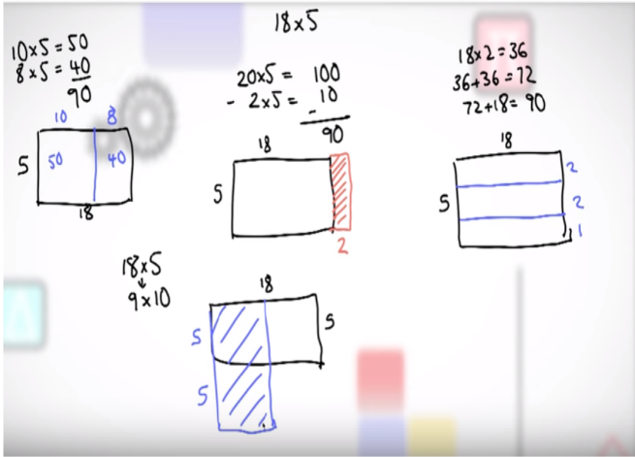

**Summary:**

1. Once students can represent a multiplication problem visually, they should complete the back practice problems with their partner. Again, no calculators should be used, but a key may be helpful so students know they are on the right track.
2. The goal, just like addition, is to show that any number can be broken up into easier parts to work with. This method of thinking works in a lot of areas in math, so it should be stressed to the students during the lesson.

**Visual Multiplication**

In the following four boxes, multiply 18 x 5 using a picture. Try and think of four different ways, or pictures, that you can use to multiply. Next to each picture, write the symbolic representation of each picture.

|  |  |
| --- | --- |
| **18 x 5 =** | **18 x 5 =** |
| **18 x 5 =** | **18 x 5 =** |

Use the rest of this space to keep notes of how other classmates solved the problem.

**Practice:** Use visual multiplication with addition by hand to multiply the following.

1. 2.

3. 4.

5. 6.

7. 8.

**Day 14: Division by Hand**

**Objective:** Students will be able to divide integers using base ten blocks

**MN State Standards:**

* 7.1.2.1 Add, subtract, multiply and divide positive and negative rational numbers that are integers, fractions and terminating decimals; use efficient and generalizable algorithms
* 8.1.1.3 Determine rational approximations for solutions to problems involving real numbers

**Materials:**

* *Dividing by Hand Teacher Note Sheet* (just for teacher reference)
* *Dividing by Hand* worksheet
* Base ten blocks

**Launch:**

1. Ask the students what it means to divide something. Different students should share their answers.
   1. Students should understand that dividing means splitting into equal parts. For example, if I had 12 cookies and 3 friends, then you would give each person a cookie until you ran out (or had an uneven amount left) and see how many each person had.
   2. This is the problem $12÷3=4$. In other words, we can ask our self how many cookies each group gets if we have 3 groups.
2. Ask students how they can check to see if their quotient is correct and let them share their answers.
   1. They should know that they can check their answer by multiplying the divisor by the quotient. For example, we know that 4 is correct because 3 x 4 = 12.

**Explore:**

1. Walk through the example on the *Dividing by Hand Teacher Note Sheet*. This should be completed with the students. Ask guiding questions (as outlined on the right) and see what answers students come up with.
2. Go with what the students are saying. This may take a little longer to get to the final answer, but students should know that there is more than one way to get the answer. They should not stress about finding the “correct” number of flats, rods, or units to put into their groups because they can start with what they know and work their way towards the final answer.
3. Once the class solves the problem one way, have students solve the same problem a little differently (in this case, the only thing that can really change is the number of rods put into each group at a time).
4. Hand out the *Division by Hand* worksheet. Students will work with their groups and base ten blocks to complete the worksheet. The worksheet is set up so that they only have to use base ten blocks on the first three problems, but students may use them to complete the entire worksheet if they wish.

**Share:**

1. Students will be working for the remainder of class on the worksheet. Students are encouraged to work together to see the variety of methods their classmates come up with.
2. Students can check their answers by multiplying as mentioned earlier or by checking with base ten blocks.

**Summary:**

1. The idea of breaking down operations into groups to create a simpler problem is reinforced in this lesson again. Eventually students will learn how to divide using long division.

**Division by Hand Teacher Note Sheet**

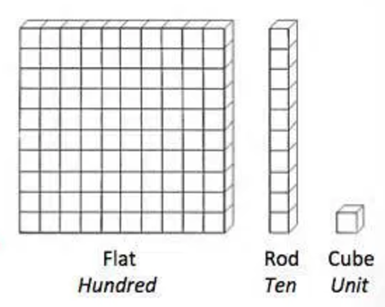

**Base 10 blocks:**

1. We are going to divide 423 by 3. **Steps:**



**423 3** 1. Grab base ten blocks to represent the number **423**.



You should have 4 flats, 2 rods, and 3 units.



2. Draw **3** circles on your desk. Dividing means you are splitting up 423 into three equal parts.



3. Look at your Flat (100) blocks. How many can you put in each group? Since there are 4, you can put one in each group, with one left over.



4. Now we have 123 left. Looking at our blocks, we only have one flat, so we are going to replace the flat with ten rods. Now, we have 12 rods, and 3 units. How many rods can you evenly break into three groups? Since there are 12 rods, you can put 4 in each group with no leftover.



5. Finally, we have 3 units left. How many units can you put in each group? Since there are 3, we can put 1 in each group with none left over.



6. Since we are out of blocks, we are done! Add the right side to get your final answer.



This is a guide for teaches. Students should be encouraged to make groups of three on their own. For example, instead of putting four rods in each group right away, students may just put one rod in each group and do this process four times. The objective is for students to see how the groups are formed, so there isn’t a single right way to solve it.

**Division by Hand**

**Base 10 blocks:**

Use an expo marker on your desk to create your groups that you are dividing into each time.

1. Find Draw a sketch of what **one** of your groups looks like

with the blocks

**112 4**

2. Find Draw a sketch of what **one** of your groups looks like

with the blocks

**215 5**

3. Find Draw a sketch of what **one** of your groups looks like

with the blocks

Try the following without using your base ten blocks, but feel free to use them if you need to.

4. Find 5. Find

6. Find 7. Find $1353÷11$

**Day 15: How Grand is Your Total?**

**Objective:** Students will use logic to place numbers into different operations to try and come up with the greatest total sum

**MN State Standards:**

* 7.1.2.1 Add, subtract, multiply and divide positive and negative rational numbers that are integers, fractions and terminating decimals; use efficient and generalizable algorithms
* 8.1.1.3 Determine rational approximations for solutions to problems involving real numbers

**Materials:**

* *How Grand Is Your Total?* Worksheet

**Launch:**

1. Review adding, subtracting, multiplying, and dividing by hand by having students complete the following: 117 + 39, 117 – 39, 117 x 39, and 117/39.
2. Students will need to have all of these skills to complete the activity.

**Explore:**

1. Students will work in their groups to fill out the *How Grand Is Your Total?* Worksheet.
2. How the activity works:
   1. There is a chart with five 9’s, five 8’s, five 7’s,…, five 0’s. Students must fill in the blank squares using the provided numbers.
   2. Students may only use the numbers in the chart, so once they use 9 five times they cannot use it anymore.
   3. The class should discuss certain rules like if 0 can be a leading digit. The class can decide how they want to do it as long as everyone is consistent.
   4. They will find their values (A – K) and list them under each operation. Then they will mark them in the chart on the right and add them up to find their grand total.
   5. The team with the highest sum wins.
3. Since students will not have calculators, suggest to the students to come up with a strategy before they just start filling in numbers. They are not going to want to sum up everything multiple times by hand.
   1. They can maybe just try switching a couple numbers around in the different operations to see which order yields a greater outcome.
   2. They should also use some logic to which orders of numbers they want to check.
   3. This will prevent them from doing a lot of tedious operations without a calculator.
4. Give students a time limit for when they need to have their final answer by.

**Share:**

1. Groups will take turns sharing their grand total sum and the strategy they came up with.
   1. The math should be double checked since students will be doing it by hand.
2. There should be a lot of discussion as to why certain numbers were placed in different spots and why certain orders led to greater changes in the sum.
3. Some topics that should come up would be which numbers should go with multiplication? With division? Where did we place all of the 9’s? What about all of the 0’s? What happens if a number in the one’s place is switched in addition or multiplication? What about if a number is switched in the tens’ place for addition and multiplication? Etc.

**Summary:**

1. As a challenge, students can work on this at home to see if they get an even bigger sum than what they found in class. If they would like, they can use a calculator for efficiency. At this point, the problem becomes more of a logic and reasoning problem than a calculation problem.

***Adapted From “How Grand Is Your Total?” by Nancy Nutting***

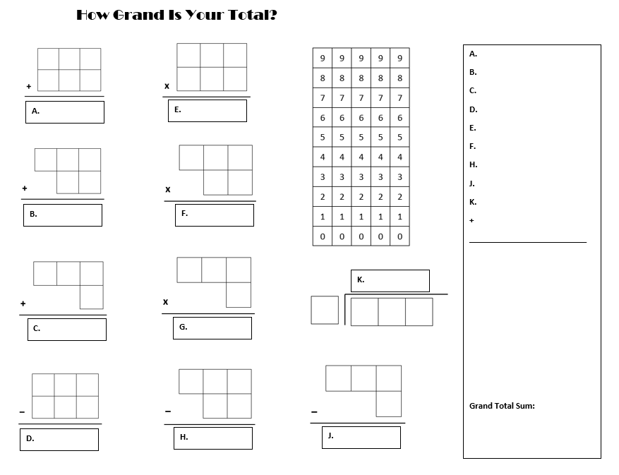

**Pre/Post-Test Number Concepts**

**No Calculator.**

1. Is 3210 divisible by: 2 3 4 5 6 7 8 9 10 (circle all that apply)

2. Write the prime factorization of 1650.

3. Find the greatest common factor and least common multiple of 24 and 36.

GCF(24,36) = __________ LCM(24,36) = __________

4. You go to the gym every 3 days. Your friend goes to the gym every 5 days. If you both go to the gym today, how many days will it be until you both are at the gym on the same day?

5. Simplify the following. Show ALL of your steps: ${(6-2)}^{2}÷3+5×4$

For each of the following operations in 6 – 9, draw a picture to represent your solution and the algebra that matches your picture.

6. Picture: Algebra:

7. Picture: Algebra:

8. Picture: Algebra:

9. Picture: Algebra: